Homework Term 5

Please select at least three pieces of homework to complete by Thursday 14th May from the menu below. Our learning this term is ‘Our European Neighbours’.

Create a word search of European countries or capital cities. | Create a booklet - Caring for our Pets  List the food they eat, and how to care for them.
Write a letter from a European destination describing the weather, land mark features etc. | Choose a European country and write a fact file about them. | Using your knowledge of Europe, create a quiz to test the class. Make sure you know the answers!
Make a 3D model of a famous landmark found in a European country. | Make a table showing some of the time differences from London to different European cities and how many miles away they are. | Describe and draw what happens when you write a word on a piece of paper and then look at it in a mirror.
Taste some European dishes. Write a food review, describing what you have eaten. | Research, draw and colour five European flags. | Research a famous sports person, singer, actor etc. from a European country and tell me about them.

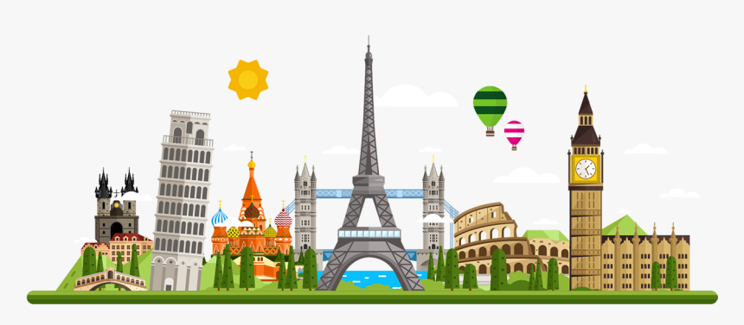
Thank you for your continuing support with your child’s learning.
Foxes

