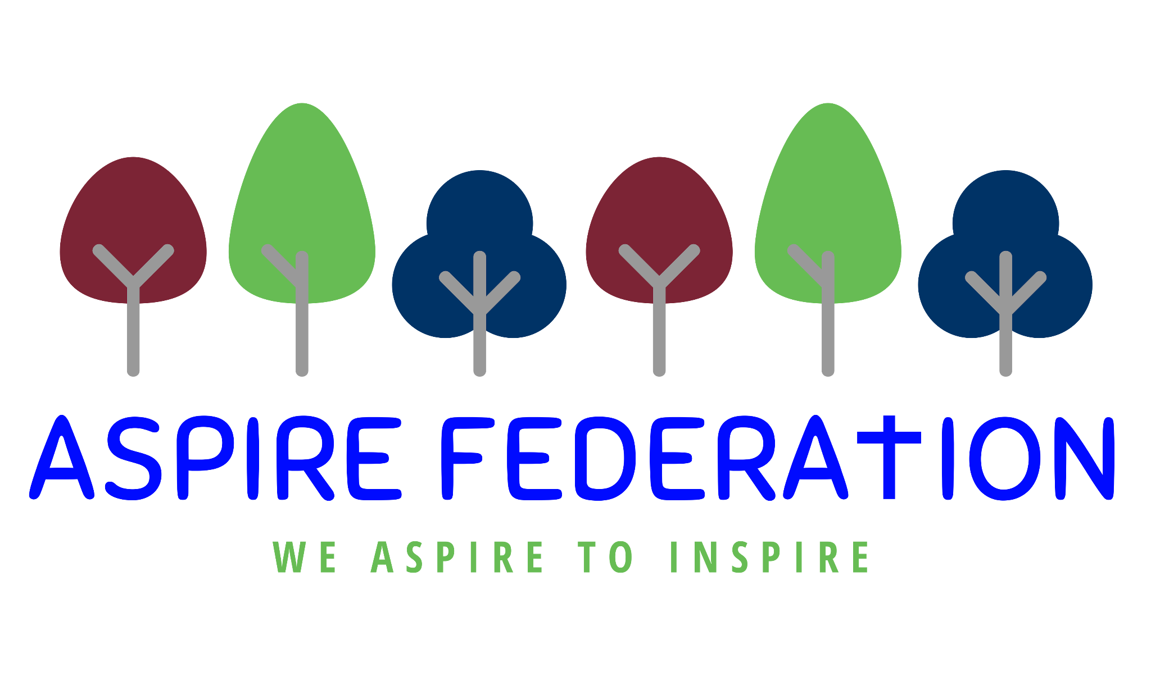

Friday 10th May 2024

Dear Parents/Carers,

I hope that you all had a good week.

I am writing with my usual weekly letter of news and information. I can be contacted at exechead@aspire-kent.org.uk between 8am - 5pm Monday to Friday for queries and questions. Also Lauren my PA can be contacted at lriby@aspire-kent.org.uk. Any requests for meetings or appointments can be made through Lauren - thank you.

Free Kent Test and Learning support for disadvantaged children-

Weald of Kent have recently introduced a partnership with Atom Learning. This is an online learning and 11+ preparation platform.

This provides FREE support for KS2 children who are eligible for Pupil Premium and free school meals who are preparing for the Kent Test.

You can access this at https://www.wealdofkent.kent.sch.uk/about/admissions/free-11-familiarisation-materials
And once the form is completed and you have confirmed your child's pupil premium or free school meals the account will be created for you to explore.
The attached leaflet also provides more information and contact details.

Lenham School Open Evenings-

Lenham School are holding open evenings for Year 5 and 6 pupils to explore their School. Tours are carried out by members of the Leadership Team who will be able to answer any questions.

The tours are on several days in June and start at 9.30am allowing you to see the school during the day.

Booking is required for this and this can be done by visiting their website- https://www.thelenham.viat.org.uk/3876/open-morning-events

Bubble Rush 2024-

Demelza are holding a Family Fun Run at Mote Park on Sunday 23rd June.

This wonderful charity delivers care to children and young people with serious or life-limiting conditions, and their families across Kent, South East London and East Sussex.

Why not join this fabulous event for a fun-filed family day to support this incredible charity. Tickets can be booked at https://www.demelza.org.uk/support-us/events/bubblerushmaidstone

Free School Meals-

For those eligible for free school meals, please check your inboxes next week as a £10 supermarket voucher, for half term will be issued for each child who is eligible. Children are eligible if they receive benefit related free school meals.

It has also been highlighted that vouchers that have been previously issued and not claimed will expire and no longer be able to be claimed. You are able to check for any unclaimed vouchers within your account at https://www.evouchers.com/

Wraparound Care Questionnaire-

I would like to draw your attention to the attached link for a questionnaire regarding wraparound care at Platts Heath and Ulcombe. Currently two of our schools have wrap-around care, Kingswood and Leeds and Broomfield. This questionnaire is to establish whether there is a need at Platts Heath or Ulcombe for wraparound provision.

Please could parents that would be interested in morning or afternoon additional childcare complete this form in order to gain an idea of the level of interest in this extra support for your children.
https://forms.gle/TBkCZ7rNRvjgxsBh7

Wishing you all a lovely and restful weekend.

Kind regards,

Emma Hickling
Executive Headteacher

