Term 4  2023-2024 | Write a diary entry as Odysseus. How did you feel when you met the Cyclops and was stuck in a cave? | Draw a picture of your own Ancient Greek god or goddess. | Create food chains for 3 of your favourite animals. Where do they fit in the chain?
Homework  1.Reading your levelled book with an adult.  2. Numbots/ TTRS - can you play for 10 minutes a day?  3. Choose one activity per week to complete and return on the last week of term. | If you had a chance to interview Alexander the Great what would you ask him? Write a few questions. | Practice 1,2,5 and 10 times tables. How quickly can you write each time table? | How many ways can you make 10/ 100. Write as many number sentences as you can.

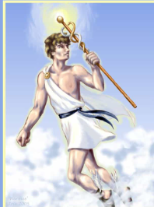

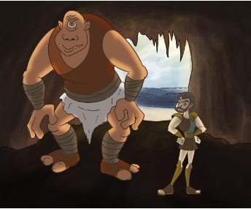
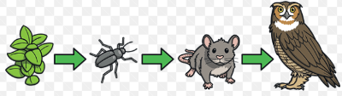
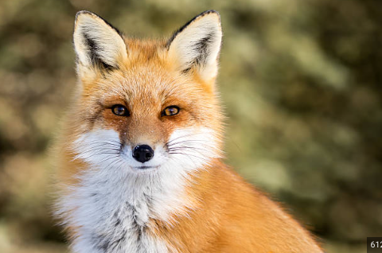

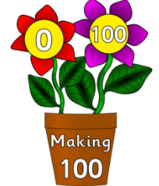
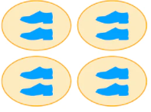
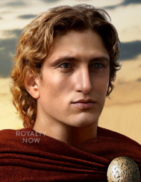

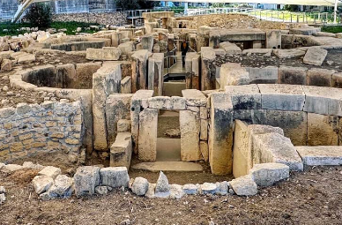
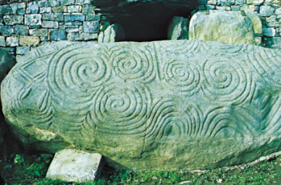
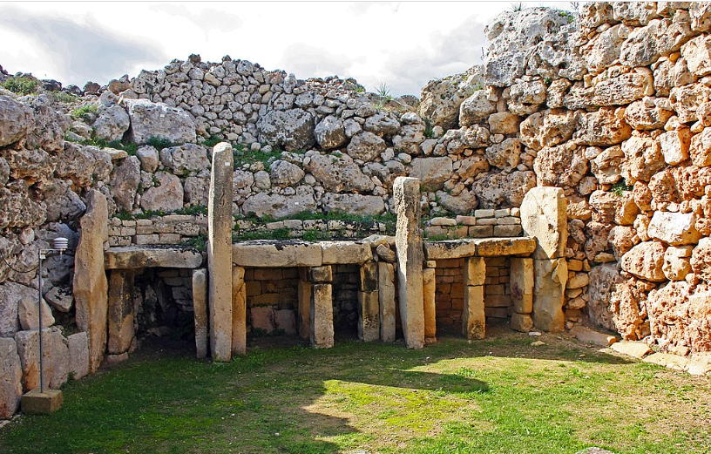
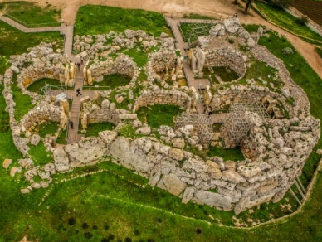
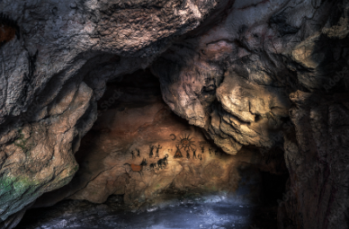
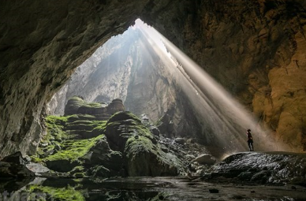

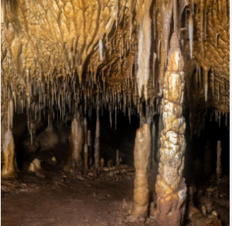

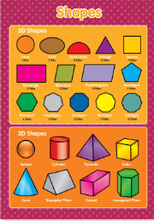

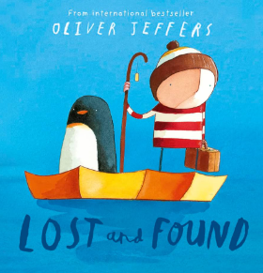

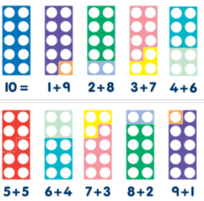

Term 1  2023-2024 | Pretend you are the boy from the stone age boy story. Write about your favourite part of the stone age. | Talk to someone you know and ask them about their childhood. How was it different from yours?  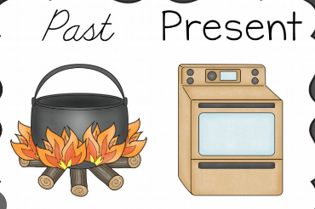 | Collect different materials around your home and garden. Can you use the materials to make your own cave? Think about their properties and whether it is suitable.  Take a picture of your cave or bring it into school.
Homework  1.Reading your levelled book  Numbots - can you play for 10 minutes a day?  Choose one activity per week to complete and return on the last week of term. | Can you visit your local library and share the books you have chosen? Which book is your favourite and why? | How many 2 digit numbers can you partition using a  part part whole model? | Can you draw your own cave? Think about the colour and the texture.

