LOOK!

Calling all practitioners and parents!

Did you know that there is a fabulous NHS website that you can visit full of helpful information created by professionals surrounding Occupational Therapy, Physiotherapy and Speech and Language Therapy?

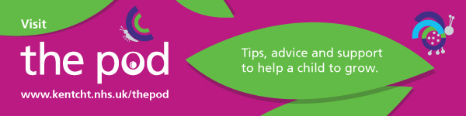

The website is full of helpful workshops, links to useful sites and information covering:

Speech and Language Therapy: Communication Aids, Autism, Bilingualism, Cleft Lip and Palate, Early Language and Communication, Feeding/Swallowing, Hearing Impairment, School Aged Language, Selective Mutism, Speech Sounds, Stammering and Voice.

Occupational Therapy: Dressing and Undressing, How to help your child learn new skills and have fun, Meal times, Movement and Coordination Skills, Pre-writing and writing, Sensory processing and strategies.

Physiotherapy: Being active, Co-ordination and gross motor movement development, Hypermobility, movement and co-ordination skills.

You can also refer children via The Pod, with more information and useful supporting documents available.

Give it a try, you might find something that can support your child!

https://www.kentcht.nhs.uk/childrens-therapies-the-pod/ | 