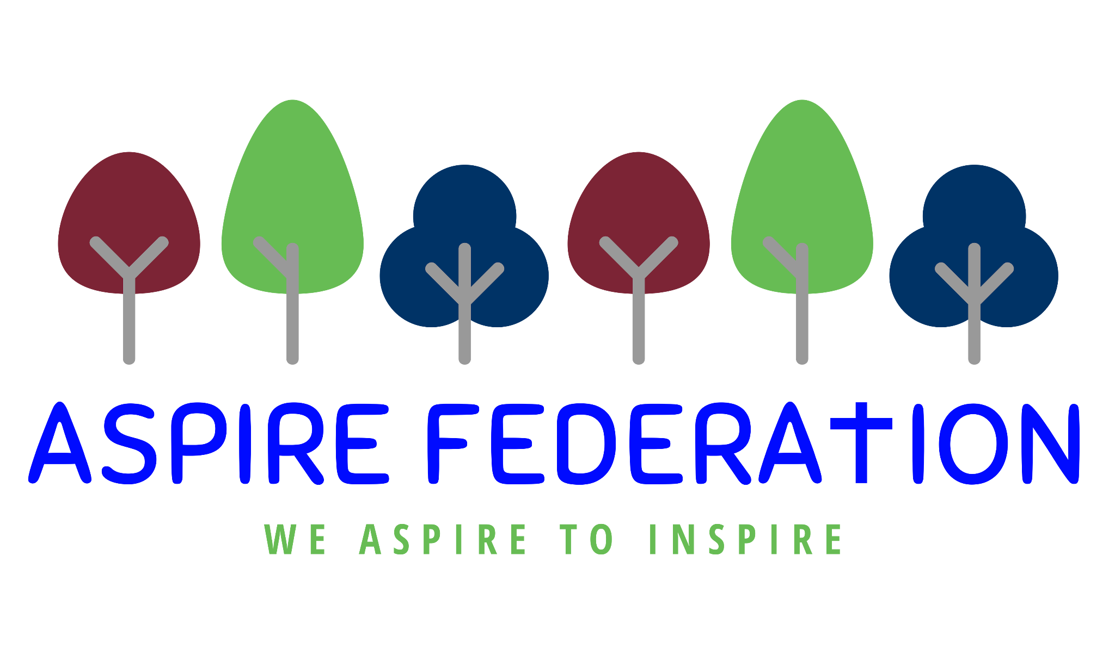

Friday 7th October 2021

Dear parents,

As we draw to the end of another week, I am writing to you with the usual round up of news and information. My daughter is getting married in the next few days and I have been granted two days leave for the occasion. I will therefore not be at school on Monday 11th October or Tuesday 12th October, I can be contacted via email atexechead@aspire-kent.org.uk
and I will reply when I can. If you need immediate support please contact one of the heads of school, or Mrs Unsworth-Brown at Platts Heath. Thank you.

Pupil - Positive Cases in Aspire

We have had two pupils test positive in the last few days. Both pupils are in upper key stage two. One is at Platts Heath and the other at Kingswood. All staff and parents have been informed. According to current guidance school remains open as normal, pupils do not need to isolate and staff have been double jabbed and also do not need to isolate.

Career Opportunities within Aspire

There are a number of positions available within the aspire schools at present, they are all advertised on the Kent Teach website - https://www.kent-teach.com/. Several are teaching assistant positions and are generally during school hours. If you are looking for work to fit around the children, please do have a look. We would love to welcome you to our team!

Parents evenings

Parents should have now been invited to sign up for an appointment at parents evening next week. If you haven't had the opportunity to do this please ask at the school office.

Parent council

This week I chaired the first parent council meeting. The heads of school were also present. Following introductions we discussed parent opinion of the new homework policy, wrap around care and future agenda items.

All parents present agreed that they were happy for their email address to be shared so that parents of the class they are representing can contact them with any suggestions of items to discuss.

The contact details are as follows.

School | Name of parent | Class | Email
Kingswood  Kingswood | Sarah Jane Humprey  Dorothea Stolton | Chestnut  Birch | madebyfaloola@aol.co.uk  dorotheastolton@gmail.com
Kingswood | Kat Harris | Oak | harriskat16@gmail.com
Ulcombe | Rachel Kenny | Owlets | rachelflynn@gmail.com
Ulcombe | Sam May | Barn Owls | sam.may23@yahoo.com
Ulcombe | Jamie Rana | Tawny Owls | jamierana78@gmail.com
Leeds and Broomfield | Claire Ayres | Hedgehogs | claireayres@gmail.com
Leeds and Broomfield | Alexandra Kershaw | Squirrels | alexandra.a.kennedy@gmail.com
Leeds and Broomfield | Kate Kent | Badgers | waghornkate@sky.com

We do now have one representative from Platts Heath - for Willow class. Unfortunately she was unable to make the meeting so I will share her contact details after the next meeting once I have gained her permission.

The minutes will be available on the aspire website, if you are interested in reading them.

Swimming

Aspire has joined the swimming charter as we are now providing our own swimming and water safety lessons. This means we will also be able to award the children badges as they progress through their lessons. Thank you to Mrs Steer and Mrs Cannell for teaching our pupils to swim.

1000 hours of Kindness

Ashford Vineyards Church are organising 1000 hours of kindness, we at Aspire are keen to join in. Here is the information from the website.

https://ashfordvineyard.org/whats-on/thousand-hours/

Thousand Hours began in Ashford in October 2016 when we decided to pledge a thousand hours of our time to bringing life to Ashford. Whether through personal volunteering in our own neighbourhoods – picking up litter, baking cakes for neighbours, etc. or collectively by putting on community events throughout the month of October, we wanted to make an impact on the town that we love by spreading acts of kindness, and bringing life in any way that we could.
Every year, Thousand Hours gets bigger and better. We now link up with schools to give them the tools to be a part of Thousand Hours too, and we are loving the relationships being built as we help teachers weave kindness into their curriculum, instilling kindness in Children’s hearts from a young age.

We are hoping to collect hours of kindness from both staff and children and these will be recorded with a slip sent home. I will write again with more details when I have them.

Wishing you lovely family weekends.

Kind regards,

Emma Hickling
Executive Headteacher
Aspire Federation

