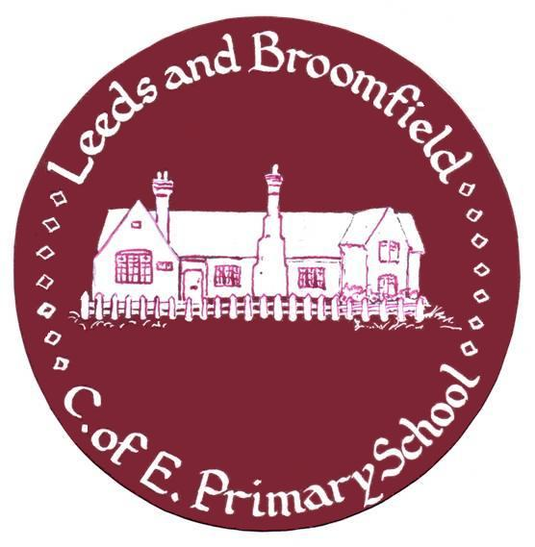Leeds and Broomfield CE Primary School

School Terms and Holidays 2021-22
June 2021
These holiday dates are set by Kent County Council. All schools are allowed a further 5 days for staff training.
 | Autumn 2021 – Term 1
Staff Training Day | Wednesday 1 September 2021
Staff Training Day | Thursday 2 September 2021
Staff Training Day | Friday 3 September 2021
Pupils Return to School | Monday 6 September 2021
Year R Start Part-time | Monday 6 September 2021
Year R Start Full-time | Monday 13 September 2021
Last Day of Term 1 | Friday 22 October 2021
Half Term | Monday 25 to Friday 29 October 2021
 | Autumn 2021 – Term 2
Pupils Return to School | Monday 1 November 2021
Last Day of Term 2 | Friday 17 December 2021
Christmas Holiday | Monday 20 December 2021 to Monday 3 January 2022
 | Spring 2022 – Term 3
Pupils Return to School | Tuesday 4 January 2022
Last Day of Term 3 | Friday 11 February 2022
Half Term | Monday 15 to Friday 19 February 2022
 | Spring 2022 – Term 4
Staff Training Day | Monday 21 February 2022
Pupils Return to School | Tuesday 22 February 2022
Last Day of Term 4 | Friday 1 April 2022
Easter Holiday | Monday 4 April to Monday 18 April 2022
 | Summer 2022 – Term 5
Pupils Return to School | Tuesday 19 April 2022
May Day Bank Holiday | Monday 2 May 2022
Last Day of Term 5 | Friday 27 May 2022
Half Term | Monday 30 May to Friday 3 June 2022
 | Summer 2022 – Term 6
Pupils Return to School | Monday 6 June 2022
Staff Training Day | Friday 1 July 2022
Last Day of Term 6 | Friday 22 July 2022

INSET (Staff Training) Days | Bank Holidays
Wednesday 1 September 2021 | Good Friday – 15 April 2022
Thursday 2 September 2021 | Easter Monday – 18 April 2022
Friday 3 September 2021 | May Day – Monday 2 May
Monday, 21 February 2022 | Spring Bank Holiday – Thursday 2 June
Friday 1 July 2022 | Platinum Jubilee Bank Holiday – Friday 3 June

