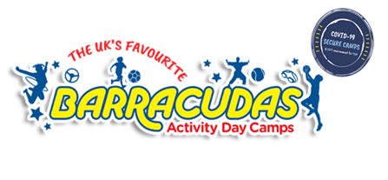

Give them something to really look forward to in the school holidays!
Whilst we might not be able to go to far-flung places just yet, your child can have a real adventure in the school holidays at an activity camp on their doorstep.
They'll get to try new activities, develop new passions and meet new friends in incredible settings at convenient locations. Barracudas has so much to offer, including:
- Unrivalled activities
- Choice for every session
- Fully qualified and trained staff
- Amazing venues
- Convenient locations
- Ofsted registered
- 5 Star Trustpilot rating
Book them in for a full week at your local Barracudas camp to give them something to get excited about!
With unrivalled activities as well as bundles of new activities for 2021, whether they’re a first timer, or seasoned Barracuda, they’ll have the BEST time every day!
Book online today or call 01480 467567
Kind regards,
The Barracudas Team

