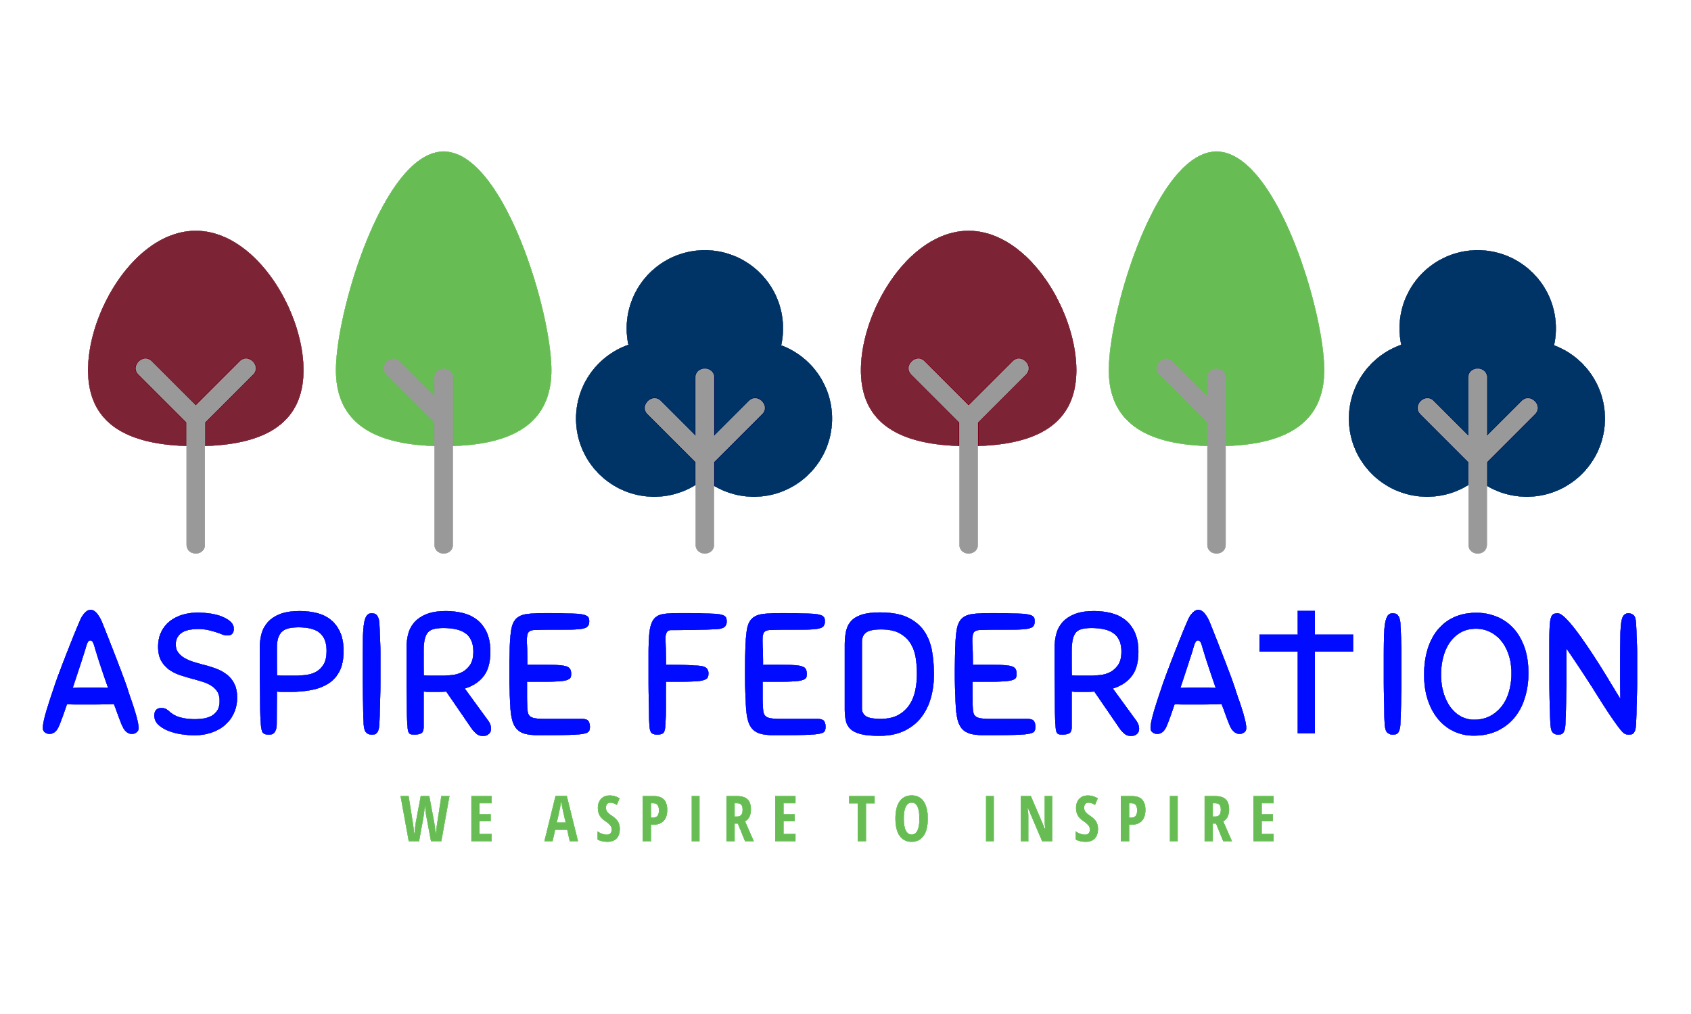
ASPIRE Federation Reopening: Risk Assessment - March 2021 The example measures we list are based on current (as at 23/02/2021) government guidance:
- Guidance for full opening: schools
- Guidance for full opening: special schools (this includes guidance on pupils with EHC plans that should be useful for mainstream schools as well)
- Actions for early years and childcare providers during the coronavirus outbreak
- Actions for education settings to prepare for wider opening
- Implementing preventative measures in education settings
- Planning guide for early years and childcare settings
- Planning guide for primary schools
- Guidance for secondary school provision
- Safe working in education settings
This document is based in the template from THE KEY – FOR SCHOOL LEADERS and brings in measures workable in our school, additional ones, and is adapted accordingly to take into account:
- The number of staff and pupils we expect to have in
- Any risk assessments for individual staff particularly for staff who are at higher risk of contracting or becoming seriously ill from coronavirus (e.g. those who are clinically vulnerable and/or who are BAME)
- Reasonable adjustments are being made to enable everyone to follow the measures, including pupils with EHC plans (e.g. Designing approaches to help children with challenging behaviour who may struggle to follow the rules)
- The size and layout of your school premises
- The resources in stock or can order easily (e.g. PPE, soap, cleaning products)

HAZARD | WHO MIGHT BE HARMED | CONTROLS TO BE PUT IN PLACE | WHO WILL BE RESPONSIBLE | WHEN THE CONTROLS NEED TO BE IN PLACE BY | ADDITIONAL NOTES
Contact with someone suffering from coronavirus | - Staff  - Pupils  - Contractors  - Visitors | Everyone will be asked not to come into school if they need to self-isolate under current guidance. Regular reminders will be given about this.  All pupils returning from a country specified on the government list of countries that are not exempt must quarantine for 14 days upon arrival in the UK  Anyone self-isolating with symptoms will be encouraged to access testing and engage with the NHS Test and Trace process.  If a symptomatic person comes into school, they will be sent home immediately or isolated until they can be picked up. The isolation room is the conservatory. 999 will be called if they are seriously ill or injured or their life is at risk.  In the case of a symptomatic pupil who needs to be supervised before being picked up:  - If a distance of 1+m can’t be maintained, supervising staff will wear a fluid-resistant surgical mask  - If contact is necessary, supervising staff will also wear disposable gloves and a disposable apron  - If there’s a risk of splashing to the eyes, such as from coughing, spitting or vomiting, supervising staff will also wear eye protection – The Head Teacher has the supply of PPE relating to this occurrence  Supervising staff will wash their hands thoroughly for 20 seconds after the pupil has been picked up.  The school will provide home testing kits – Parents, carers will be encouraged to be tested via NHS drive in sites as the results arrive quicker  Staff will not take symptomatic children home themselves,  A deep clean will take place in the areas that the symptomatic person has been in, and PPE will be disposed of properly, following decontamination guidance.  If the school becomes aware that a pupil or a staff member has tested positive for coronavirus, the school will contact the local health protection team. The team will carry out a rapid risk assessment to confirm who’s been in close contact with the person, and these people will be asked to self-isolate.  To help with this, records will be kept of:  - The pupils and staff in each group  - Any close contact that takes place between children and staff in different groups  Close contact means:  - Direct close contact – face-to-face contact with an infected person for any length of time, within 1 metre, including:  - Being coughed on,  - A face-to-face conversation, or  - Unprotected physical contact (skin-to-skin)  - Proximity contacts – extended close contact (within 1 to 2 metres for more than 15 minutes) with an infected person  - Travelling in a small car with an infected person  If there are 2 or more confirmed cases within 14 days, or an overall rise in sickness absence where coronavirus is suspected, the school will work with the local health protection team to decide if additional action is needed. Any advice given by the team will be followed.  Staff in primary schools will continue to test with LFDs twice a week at home, as per existing guidance on testing for staff in primary schools. | Parents / guardians are responsible to let the school and class teacher know they or anyone they live with is experiencing coronavirus symptoms,  Class teachers are to let the Headteacher know if they or anyone they live with is experiencing coronavirus symptoms,  The head teacher will let the chair of governors know if she or anyone they live with is experiencing coronavirus symptoms,  The chair of governors and the head teacher will send out a message to the parents groups as well as contact the relevant authorities | September 2nd  8/3/2021 | key Information from this section sent to parents 5/3/2021  Information shared with staff in pre -reopening meetings 24/2/2021  This document to be shared with staff and governors for feedback 24/2/2021
Contact with coronavirus when getting to and from school |  | Everyone will be encouraged to walk or cycle or drive alone into school, and asked to avoid taking public transport during peak times if possible. Anyone arriving by public transport will be asked to pack away in a sealed plastic bag or dispose of their worn mask when arriving on site.  Anyone who needs to take public transport will be referred to government guidance.  School transport will not be running (i.e. buses, minivans), via the school at this time. This will be reviewed at a later date and if reinstated risk assessments will be carried out prior and assessed against being able to::  - Follow hygiene rules  - Try to keep their distance from passengers where possible  - Do not work if they or a member of their household are displaying coronavirus symptoms  Parents/carers who need to drop off and pick up pupils will be told through messages and signage:  - Their allocated drop off and collection times, with different groups being given different times  - The protocols for minimising adult to adult contact:  - Children with siblings will be dropped of and collected at the same time as the eldest sibling.  - That only one parent/carer should attend  - Not to gather at entrance gates or doors, or enter the site unless they have a pre-arranged appointment  Anyone wearing non-disposable face coverings when arriving to school will be expected to bring a plastic bag to keep these in during the school day. If they’re using disposable face coverings, these will be put in a covered bin.  Pupils wearing any sort of face covering when arriving to school will wash their hands on arrival (as all pupils will), dispose of/store the covering, and wash their hands again before going to their classroom.  Pupils will be made aware that they mustn’t touch the front of the covering during use or removal. | Head teacher along with H&S governor drafted drop and pick up procedures to be shared with parents and staff prior to opening  to be sent 28/8/20 | Dropping and Picking up procedures agreed prior to opening with staff at H&S meeting 31/8/20
Spreading infection due to touch, sneezes and coughs |  | Handwashing facilities will be provided. Handwashing facilities will be provided with soap and water. Staff and students will also use the sinks and soap in their own classrooms to wash hands.  Parents may send in anti- bacterial hand gel for their child to use and not share. It is also available in all classrooms  Everyone in school will:  - Frequently wash their hands with soap and water for 20 seconds and dry thoroughly using NHS guidelines, or use alcohol-based hand sanitiser brought from home to cover all parts of their hands  - Clean their hands on arrival, after breaks, if they change rooms, before and after eating, and after sneezing or coughing  - Be encouraged not to touch their mouth, eyes and nose  - Use a tissue or elbow to cough or sneeze, and use bins for tissue waste  Pupils will be encouraged to learn and practise these habits in lessons and by posters put up across the school.  Help will be available for any pupils who have trouble cleaning their hands independently. Skin friendly cleaning wipes can be used as an alternative. Young children will be supervised during hand washing.  Supplies for soap, hand sanitiser and disposable paper towels and tissues will be topped up regularly and monitored to make sure they’re not close to running out.  Lidded bins for tissues, preferably operated by a foot pedal, will be emptied on a schedule leaving 72 hours before opening. | Head teacher along with the Health and Safety officer will review with teaching staff their cleaning responsibilities outlined here to help reduce cross contamination.  Class teachers will be responsible for disinfecting classroom resources and desks  The head will share this information and discuss with cleaning staff.  This will including cleaning and disinfecting overnight of floors, desks, toilets and frequently touched surfaces such as light switches, door handles, taps and sinks |  | Teachers will liaise with the headteacher and H&S governor relating to resources and ongoing changes to be implemented
Spreading infection through contact with coronavirus on surfaces |  | Soft Furnishings have been removed to help reduce the spread of infections.  Pupils and parents/carers will be asked to limit the amount of equipment they bring into school each day to essentials like bags, lunch boxes, hats, coats, books, stationery and mobile phones.  Areas of the school that are used by pupils will be cleaned thoroughly at the end of the day. This is the cloakrooms and toilet areas and classrooms.  Areas of the school not in use will be shut off to make cleaning more manageable.  Cleaning staff will regularly clean frequently touched surfaces using standard cleaning products (e.g. bleach, detergent), including:  - Classroom desks and tables  - Bathroom facilities (including taps and flush buttons)  - Door and window handles  - Light switches  - Reception desks  - floors in the used classrooms, entrance areas and toilet areas  Classroom teachers will clean between groups  - Computer equipment (including keyboards and mouse) if that is shared  - Hard toys  Any resources shared between groups, such as sports, art and science equipment, will be either:  - Cleaned frequently and meticulously, and always between groups using them; or  - Rotated so they can be unused and out of reach for 48 hours (72 hours for plastics) between use by different groups  .  Individual and very frequently used equipment, like pens and pencils, will not be shared. The parents/ school will provide children with individual stationery packs for commonly used items.  Therapy equipment, such as physiotherapy or sensory equipment, will be cleaned between each use. If this is not possible or practical, it will be:  - Restricted to one user; or  - Rotated so it can be unused for 48 hours (72 hours for plastics) between use by different individuals  Shared rooms, such as halls, will be cleaned between different groups using them ( tables wiped down etc)  Antibacterial hand soap supplies given to teachers for their classrooms  Areas of the school that are used by pupils will be cleaned thoroughly at the end of the day or early in the morning  If a person with coronavirus symptoms comes into school, a deep clean will take place in the areas that the person has been in, following decontamination guidance.  Cleaning supplies will be topped up regularly and monitored to make sure they’re not close to running out.  Teachers will wash their hands and surfaces before and after handling pupils’ books. | Class Teachers will be responsible for their class setting and class resources – they know what equipment has been used by whom and can plan the use of resources for their teaching and learning |  | Teachers will liaise with the headteacher and H&S governor relating to resources and ongoing changes to be implemented
Spreading infection due to excessive contact and mixing between pupils and staff in lessons |  | Pupils will be kept to their class groups/ bubbles  Where pupils are old enough and capable enough, they will be taught and reminded to maintain their distance and not touch staff or peers.  Pupils will be seated side-by-side and facing forwards, and unnecessary furniture will be moved out of classrooms to allow for this.  Lessons that involve singing, chanting, shouting or playing instruments (particularly wind or brass instruments) will be limited to no more than 15 pupils, and will take place outside wherever possible (if taking place inside, the space will be well ventilated). Pupils will be positioned either back-to-back or side-to-side at an appropriate distance. Instruments won’t be shared. Singing or instrument playing won’t take place in any larger groups such as choirs or assemblies.  Morning break times will be staggered  For physical activity, contact sports will be avoided. Outdoor sports will be prioritised where possible, or large indoor spaces used where it is not. Distance between pupils will be maximised as much as possible.  Staff can work across different groups in order to deliver the school timetable, but they will keep their distance from pupils and other staff as much as they can (ideally 1+ or 2 metres apart). This won’t always be possible, particularly when working with younger children, but close face-to-face contact will be avoided, and time spent within 1 metre will be minimised.  Any pupils with complex needs or who need close contact care will have the same support as normal as distancing isn’t possible here. Staff will be rigorous about hand washing and respiratory hygiene.  Supply teachers, peripatetic teachers and other temporary staff will be told to minimise contact and maintain as much distance as possible from other staff. The number of temporary staff entering the school premises will be kept to a minimum.  Specialists, therapists, clinicians and other support staff for pupils with SEND should provide interventions as usual. These staff will be advised to be rigorous about hand washing and respiratory hygiene. | Teachers will be responsible for the children in their class group. |  | Teachers will liaise with the headteacher and H&S governor relating to resources and ongoing changes to be implemented
Spreading infection due to excessive contact and mixing between pupils and staff around and outside of the school |  | Pupils will be kept in the same groups at all times each day, and be kept separate from other groups. KS2 will take part in outdoor sport together once a week.  Pupil groups will have separate areas to play at break times and will eat lunch in designated areas at staggered times in the hall. Movement around the school site will be kept to a minimum.  Pupils will be supervised at all times to ensure mixing between groups doesn’t occur, and they will be reminded about the rules throughout the day.  All shared rooms, such as the hall and dining area, will be kept at half capacity to allow groups to keep apart when using them. They will be cleaned between each use.  Toilet use will be managed to avoid crowding. Only one child per year group will be allowed at a time. Staff use of staff rooms and offices will be staggered to limit occupancy/ staff to eat lunch in bubble rooms  Adult will wipe down surfaces they have come in contact with in the w/c facilities.  Year 1 and 2 children will use the individual sink and toilet marked for their class. For KS 2, the student toilet cubicles will be separated for each class instead of male and female, and the sinks will be sign posted for the Year 3&4 and Year 5&6.  Visitors to the site, such as contractors, will have guidance on physical distancing and hygiene explained to them on or before arrival. Visitors must wear facial coverings while on the premises. Any staff answering the door to visitors must wear face covering when administering temperature checks. Visits will happen outside of school hours wherever possible. A record will be kept of all visitors.  Non-overnight domestic educational visits can take place in the same pupil groups, but only subject to a separate risk assessment that considers the coronavirus measures in place at the destination. At this time no trips are planned. | Teachers will be responsible for the children in their class group and the areas that they use.  The headteacher will be responsible for the school site and delegating usage of space outside classrooms |  | Teachers will liaise with the headteacher and H&S governor relating to resources and ongoing changes to be implemented
Spreading infection due to the school environment |  | Checks to the premises will be done to make sure the school is up to health and safety standards before opening  Fire, first aid and emergency procedures have been reviewed to make sure they can still be followed with limited staff and changes to how the school space is being used.  Areas in use will be well ventilated by opening windows or using ventilation units. Doors will be propped open, where fire safety and safeguarding wouldn’t be compromised.  Lidded bins will be provided in classrooms and other key locations to dispose of tissues and any other waste.  Outdoor space will be used for exercise and breaks, and outdoor assemblies  Sanitiser will be available at the door.  Face coverings should be worn by staff and adult visitors in situations where social distancing between adults is not possible (for example, when moving around in corridors and communal areas). Children in primary school do not need to wear a face covering. | H&S governor and Head Teacher and teaching staff to have a joint site risk assessment 31/8/20  Fire system check to be carried out by H&S governor at the same meeting time.  Deputy fire marshal duties and training provided on 31/8//20 with relevant staff. | 8/3/2021
Spreading infection due to excessive contact and mixing in meetings |  | Where possible, all meetings will be conducted by telephone or using video conferencing. This includes meetings with staff, parents/carers, visitors and governors. | The headteacher will be responsible for scheduling and monitoring of these.
Individuals vulnerable to serious infection coming into school |  | The school will continue to follow any government guidance in place to decide who should come into school.  If the guidance is changed or updated, staff and families of pupils who are affected by the changes will be informed of the changes.  Staff who are clinically vulnerable or clinically extremely vulnerable and coming into school will be placed in the safest possible on-site roles where it’s possible to maintain social distancing.  Online learning platforms such as Google Classrooms will continue to be used to support learning and will focus primarily on Maths and English to enable teachers and students to continue with the progress made in the use and implementation of such learning platforms that were made during the past academic year. | Staff are responsible to highlight to the headteacher and specific individual needs  Parents are responsible to highlight to the class teacher any specific individual needs of students

