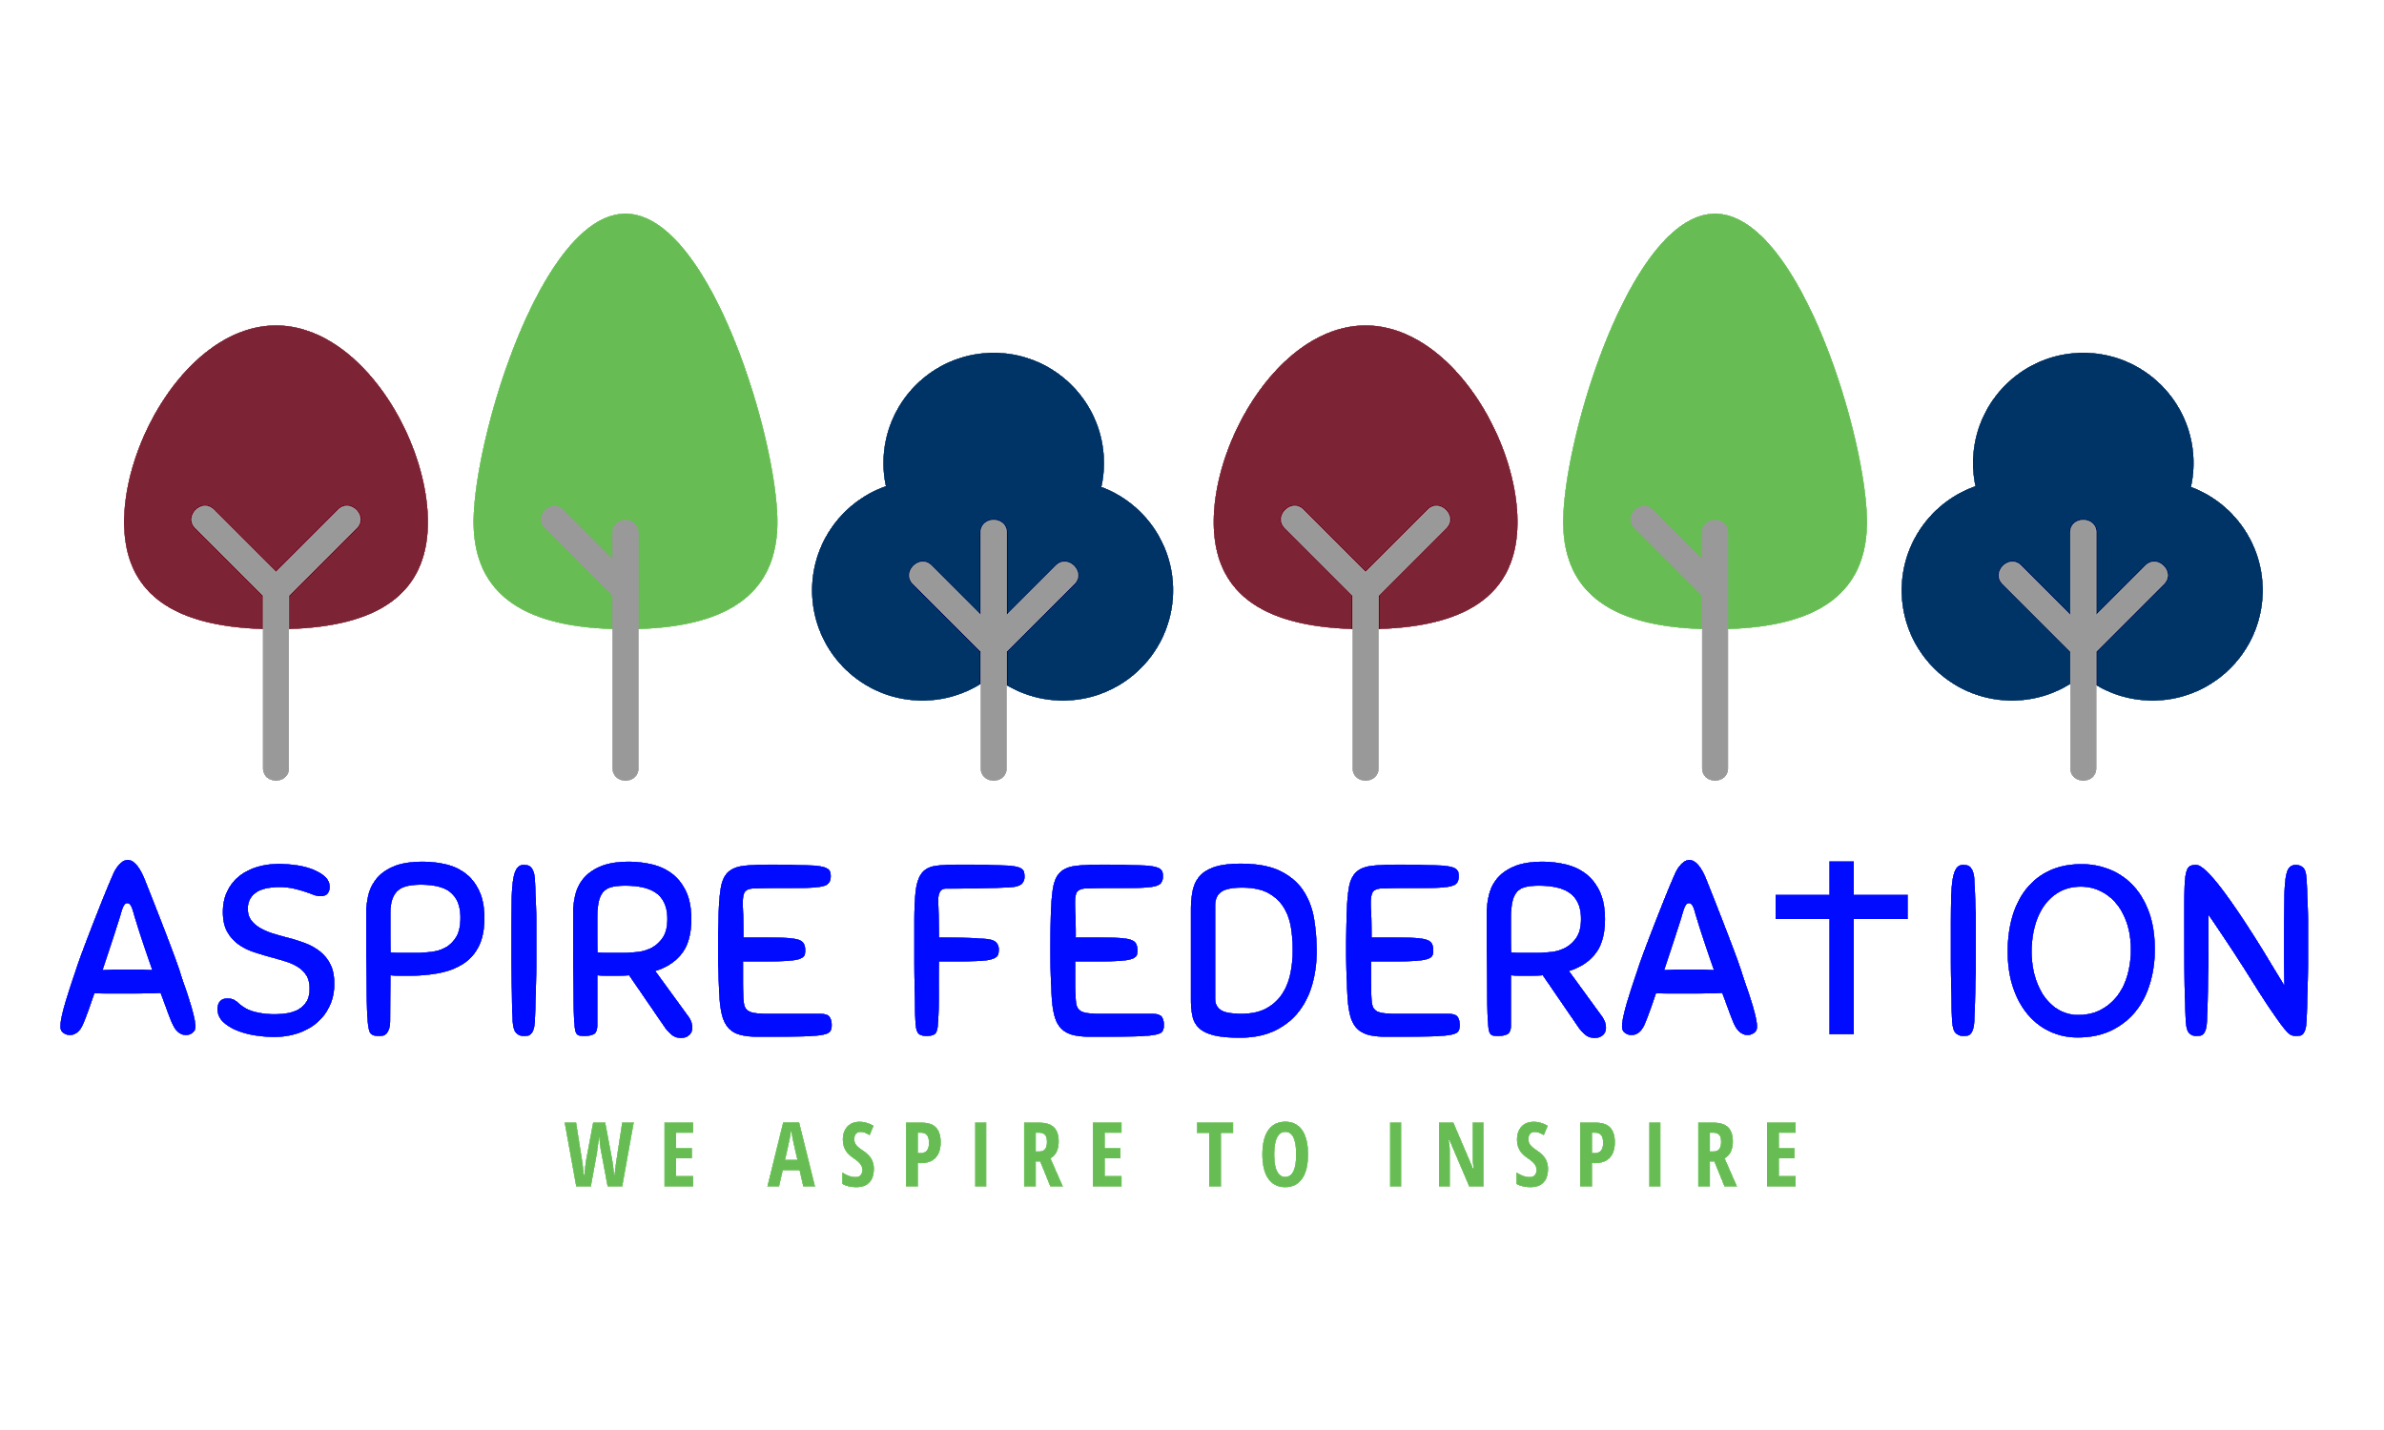
Friday 15th January 2021

Dear parents,

I am writing to you at the end of our second week of remote learning - thank you so much for your support, and all the positive comments we have had about the use of google classroom. The staff have been working very hard to make it work for everyone, as well as taking their turn working in school with the children attending. This week I have a few updates and some new information for you.

Google classroom - safeguarding

Just a reminder of the ASPIRE remote education policy - when your child joins a live lesson with their teacher or teaching assistant, there should be no filming, taking of photos or posting to social media. We have had no incidences within ASPIRE but are aware of another school that has. It is also good practice for both staff and children if they are accessing google classroom in a room with a plain background , so there are no distractions. You can also choose a google background within google meet if that is easier. Please ask your child’s class teacher if you are unsure.

Fruit for the children in school

Thanks to Friends of Kingswood school for their generous donation and to St Nicholas’ church in Grafty Green for a weekly donation which has enabled us to purchase fruit for the children who are attending school to enjoy at breaktime, whilst our usual supplier isnt delivering during lock down.

Super market vouchers for free school meal pupils

Those parents whose children normally receive a free school meal as they are on a low income or on certain benefits have been receiving supermarket vouchers through an online system called wonde, for the last couple of weeks. From next week the system used will change back to Edenred - the national system which was in place in the March 2020 lock down. The amount in vouchers will be £15 per week per child, and these mayne sent to you in one block or on a weekly basis. Please contact your child’s school office by email, if you have any queries. All children will still need a packed lunch if attending school- thanks.

Fairshare

In order to continue to support our families who have been hardest hit by the pandemic, I have been working with an organisation called Fairshare. They ensure no left over food from a supermarket goes to waste. I am pleased to inform you we have been linked with Tesco Express in Kennington, Ashford and each Tuesday we are able to collect short dated fruit, vegetables and bakery items. These will then be used within school and delivered to ASPIRE families who need the helping hand at the moment. This will be a weekly delivery so will provide our families with some fresh food on a regular basis. This is completely free of charge to ASPIRE and so we look forward to working with fair share and tescos.

Suitable clothing for using google classroom

Please can I remind all adults and pupils who are using google classroom that you can be seen when your child is in a live lesson and that all need to be fully dressed. We do understand that you are at home and relaxing but please make sure to enter the room where your child is accessing the classroom with a top on. Thank you

Weekly Testing in primary schools

You will recall I wrote to you before christmas about weekly covid testing in primary schools. The DFE have confirmed that this will be for staff only, and will start the week beginning 25th January 2021. There is some training on Monday and Tuesday next week, so once I have attended this I will adjust the plan I wrote before christmas, to ensure staff on site are tested weekly whilst we are operating out of Kingswood, and then at each of the four schools once we are able to be back in school.

Thank you for your ongoing support, as ever I can be contacted on exechead@aspire-kent.org.uk with any queries or questions.

Wishing you all relaxing family weekends

Kind regards,

Emma Hickling
Executive Headteacher
ASPIRE Federation

