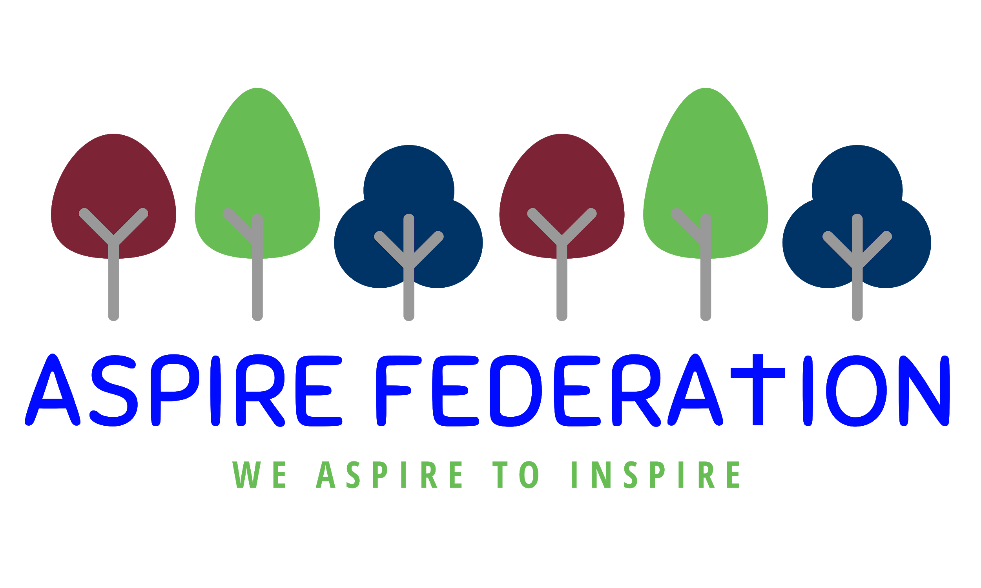 Friday 22nd January 2021

Dear parents,

I am writing to you at the end of the third week of remote learning. Thank you for all your support and suggestions, the way we are delivering the lessons. Please do continue to communicate with your child’s class teacher and head of school. We will be following up with families where children are not engaging to support in whichever we way we can.

Fair share - Tesco donations of food

Following the lack of donation last week, I have been liaising with the charity, the donations are dependent on food left over from the supermarket plus the number of groups collecting donations. This does mean that we may not have a donation each week. I have now signed up with another supermarket which will give us double the chance. The collection day for the second one is Sunday so I will be able to bring any donation into school on a Monday. I think the best way to proceed is that I will continue to work with the charity and tescos and will alert parents via text when there is a donation with details of when food can be collected. Thank you for your understanding.

Weekly testing of staff for Covid 19

From monday 25th January 2021 ASPIRE staff will be using lateral covid tests at home twice a week, on a Sunday and a Wednesday. The staff will be reporting their result to their team leader whilst they are in teams A/B/C and to their head of school when we return to our normal schools.

These tests are not as accurate as the normal test, but if a positive result is received by a member of staff, that member of staff and their bubble ( at Kingswood - if they are on site ) will need to isolate until they have attended a drive through centre for a test. If the second test is negative, all can return to school, if positive all must isolate for 10 days.

The purpose of this testing is of course to keep both adults and children safe, especially as one in three people suffering with Covid are asymptomatic.

Fruit in school

We are now in receipt of fruit deliveries at Kingswood for all those children who are attending. We have also had generous donations from both the church at Ulcombe and the one at Grafty Green, to help support us to ensure the children can have a healthy snack at break time.

Numbers of children attending school

Unlike the last lockdown where we had relatively low numbers on site at Kingswood, each of our bubbles are now between 15-22. Although the government has not capped class sizes this time, logic would suggest that the smaller I can keep the classes the safer for both staff and children. Therefore I am applying a cap of 20 pupils, so this means that the year 3/4 class is now full, in fact it is oversubscribed.

If you need a place for your child at Kingswood as you are a key/ critical worker or your family has an attached social worker or your child has an EHCP please contact me at exechead@aspire-kent.org.uk and I will try my best to assist you.

Phonics screening results

If your child is in year 2 they will have completed the phonics screening test before christmas. You should have now received the result of this, if you have any questions about your child’s performance please contact their class teacher. We congratulate all year 2 on their hard work and efforts in preparing for this test

Other tests - 2021.
As far as we know all other tests for this year including SATS are cancelled for this year. Please contact your child’s head of school if you have any queries.

Thank you for all your hard work both in your own jobs and at home with your children, Wishing you all restful family weekends. Keep well and safe,

Kind regards

Emma Hickling
Executive headteacher
ASPIRE federation

