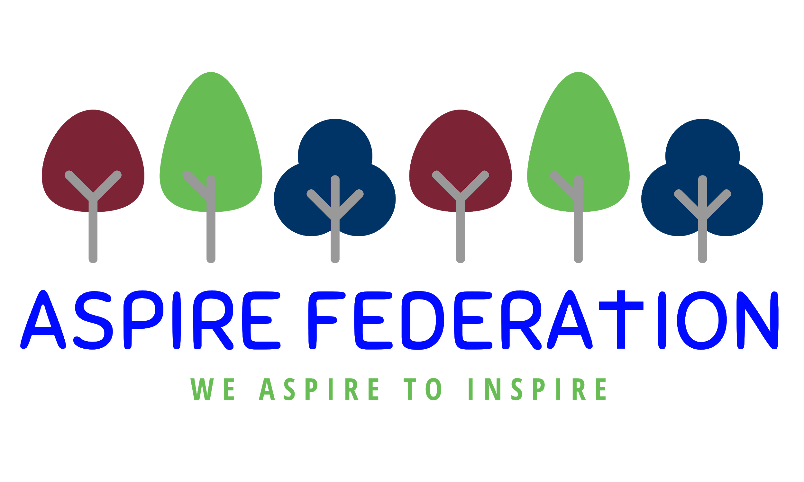
Remote education provision: information for parents

This information is intended to provide clarity and transparency to pupils and parents or carers about what to expect from remote education if local restrictions require entire cohorts (or bubbles) to remain at home.
For details of what to expect where individual pupils are self-isolating, please see the final section of this page.

The remote curriculum: what is taught to pupils at home
A pupil’s first day or two of being educated remotely might look different from our standard approach, while we take all necessary actions to prepare for a longer period of remote teaching.

What should my child expect from immediate remote education in the first day or two of pupils being sent home?

Pupils will be provided with a work pack for the first 1-2 days of a bubble closure, this should be worked through at home. This will give the teachers time to prepare their remote classroom for access. Parents will be informed by email when the remote classrooms will be ready to access.

Following the first few days of remote education, will my child be taught broadly the same curriculum as they would if they were in school?

We aim to teach the same curriculum as if we were in school, however some practical subjects such as music, PE and DT will need adaptation. This is because we cannot assume that children will have the same equipment at home as we do in school. These subjects will be taught through challenges which pupils can interpret and produce what they are able to.

Remote teaching and study time each day

How long can I expect work set by the school to take my child each day?
We expect that remote education (including remote teaching and independent work) will take pupils broadly the following number of hours each day:
Primary school-aged pupils | Early years and key stage 1 - 3 hours  One hour maths activties  One hour - English activities  One hour - topic/ creative learning  Key stage 2 pupils - 4 hours  One hour maths activties  One hour - English activities  Two hour - topic/ science/ creative learning

Accessing remote education

How will my child access any online remote education you are providing?

We are using Google classroom to deliver remote education. Pupils need an internet connection. All have been issued with their google log in

If my child does not have digital or online access at home, how will you support them to access remote education?
We recognise that some pupils may not have suitable online access at home. We take the following approaches to support those pupils to access remote education:

We have a limited number of DFE issued chrome books which can be lent to parents.

We will also send out work packs to children who cannot access the internet.

However during the first lockdown all pupils were able to access emailed work packs which would suggest that all have some form of internet access

How will my child be taught remotely?
We use a combination of the following approaches to teach pupils remotely:
Google classroom will be the way we deliver remote education. This will be a combination of live teaching and work assigned through google classroom. There is no expectation for teachers to be live teaching for 3-4, but there will be at least one opportunity daily for a live lesson.

Engagement and feedback

What are your expectations for my child’s engagement and the support that we as parents and carers should provide at home?
Pupils in key stage 1 will need some support to access Google classroom and may need some support with their learning. The activities will be set at a level that they can complete them, but they need some help accessing equipment and engaging with the lessons.
Pupils in key stage 2 will need some help ensuring that

How will you check whether my child is engaging with their work and how will I be informed if there are concerns?

Parents will be contacted weekly if their child is not engaging with google classroom and if there are concerns regarding the work submitted. Parents can contact the head of school if they are having issues with internet access and support will be given.

How will you assess my child’s work and progress?

Feedback can take many forms and may not always mean extensive written comments for individual children. For example, whole-class feedback or quizzes marked automatically via digital platforms are also valid and effective methods, amongst many others. Our approach to feeding back on pupil work is as follows: when pupils submit work this will receive feedback some may be a comment whereas other work will be marked as correct or incorrect, depending on the task. Feedback will be given daily, just as in school.

Additional support for pupils with particular needs

How will you work with me to help my child who needs additional support from adults at home to access remote education?
We recognise that some pupils, for example some pupils with special educational needs and disabilities (SEND), may not be able to access remote education without support from adults at home. We acknowledge the difficulties this may place on families, and we will work with parents and carers to support those pupils in the following ways:
Task will be differentiated so that all pupils are working at a level that they are capable. If a pupil normally has one to one support within class, this TA will be available within google classroom to support the pupil.

Remote education for self-isolating pupils
Where individual pupils need to self-isolate but the majority of their peer group remains in school, how remote education is provided will likely differ from the approach for whole groups. This is due to the challenges of teaching pupils both at home and in school.

If my child is not in school because they are self-isolating, how will their remote education differ from the approaches described above?

If a child is self isolating and the rest of their bubble is in school, work will be provided by work pack, which will be emailed to the parent. The reason for this is that their teacher will be teaching the class so is unable to access google classroom.
The learning pack will contain the activities that the other pupils will be accessing in class

Emma Hickling
December 2020

