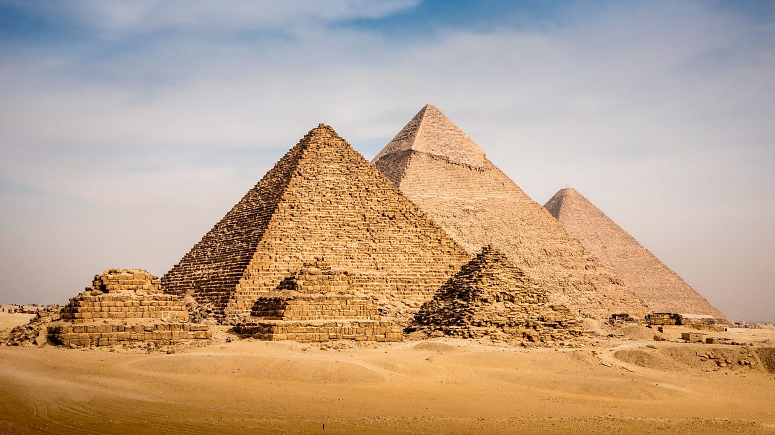

**Maths**

Our times tables are a big focus this term. You all know which ones you are struggling with as so which ones you should be looking at when at home. You all have your TT Rockstars logins and you should be logging on most days and playing. You also need to make sure that you are familiar with the inverse of these tables, eg if 8x9=72, what does 72/9=?

We are going to having daily quizzes and we all want you to be getting full marks!

**Art and design**

The Egyptians loved their jewellery! Design 2-D or 3-D Egyptian-style jewellery that any pharaoh would be proud to wear. If you choose to create jewellery that we could wear, bring in it into school so that we can add it to our Pharaohs working wall. Do people still wear Egyptian inspired jewellery? Can you find some examples and include them in your work?

**Design and technology**

Make a model pyramid from building blocks – how high can you go? Photograph your achievement and record the number of blocks you used. Can you see a pattern emerging as you build different sized pyramids? Do you know what these numbers are called? How can we work out these numbers?

If you would like to create a pyramid out of any other materials then we would love to see it.

**English**

Find out why animals were so important to the Egyptians. Create an information booklet to show your findings, combining text and images. Don’t forget to include a contents page as well as a glossary and an index. Why do we use a glossary, index and contents? Do we find these in all of our books?

We are always keen to add to our class books so we are looking forward to being able to share your amazing work.

**School values**

Our school Christian values are something that we think about every day in school and we would like this to continue at home. Are you **curious** at home? Do you show **resilience**? Are you **honest**? How can you show **empathy** at home? Are you always showing **respect** to those around you?

Think about these values at all times, not just when you’re in school. (You do not need to write anything for this, we would just like you to think about them throughout your time at home, just as you do in school.)

**PSHE**

Friday was World Mental Health Day and yellow was the colour of choice! We spoke a lot about how we can support each other to feel better about ourselves, focusing on positives rather that the negatives. How can you help those around you to feel better about themselves? Can you come up with any positive sayings that we can display in the classroom? One of my favourites is ‘It’s OK not to know, it’s not OK not to try.’ We are all here to help and support each other, both in school and at home.

We have begun a new topic this week which will continue until Christmas. (Yes I mentioned that word!) These activities are for you to complete over the next few weeks and not all at once!

Please send your work to our class email so that we can celebrate in your achievements!

Alongside this work, you also need to be reading every day as well as learning your spellings. When reading, if you come across a word that you are unsure of, look it up and find out what it means. This could be used in your English work both in school and at home. We are always excited to learn and use new words.

Mrs Cannell and Mrs Coleman

**Ancient Egyptians**

**Badgers home learning**