Leeds and Broomfield Primary School 2020-2021
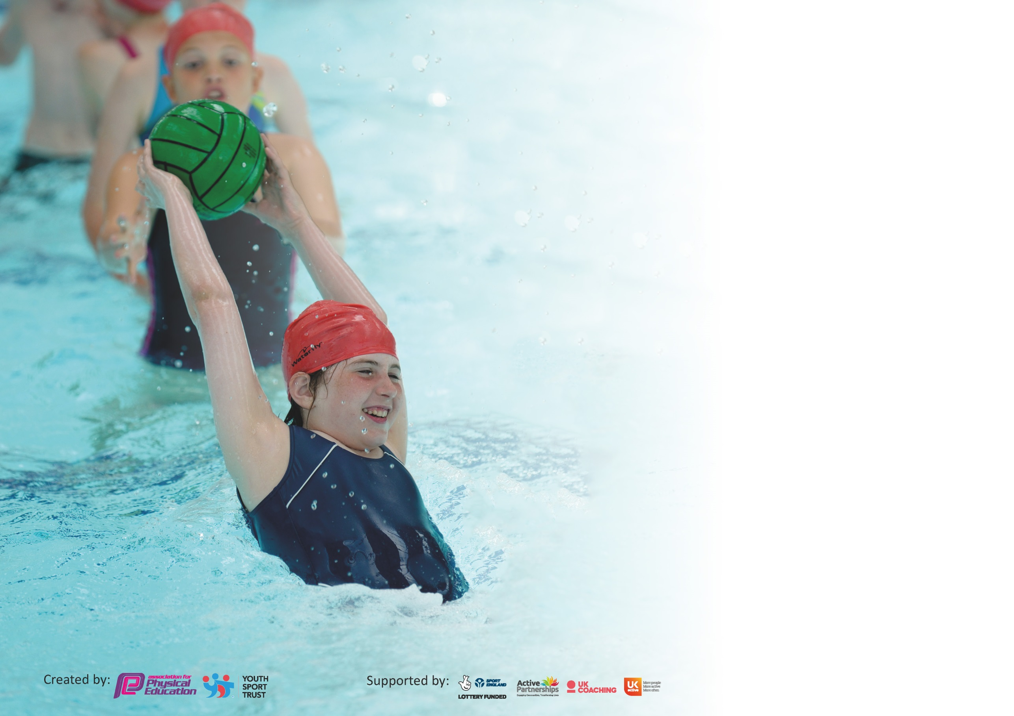

It is important that your grant is used effectively and based on school need. The Education Inspection Framework (Ofsted 2019 p64) makes clear there will be a focus on ‘whether leaders and those responsible for governors all understand their respective roles and perform these in a way that enhances the effectiveness of the school’.

Under the Quality of Education criteria (p41) inspectors consider the extent to which schools can articulate their curriculum (INTENT), construct their curriculum (IMPLEMENTATION) and demonstrate the outcomes which result (IMPACT).

To assist schools with common transferable language this template has been developed to utilise the same three headings which should make your plans easily transferable between working documents.

Schools must use the funding to make additional and sustainable improvements to the quality of Physical Education, School Sport and Physical Activity (PESSPA) they offer. This means that you should
use the Primary PE and Sport Premium to:

- Develop or add to the PESSPA activities that your school already offer
- Build capacity and capability within the school to ensure that improvements made now will benefit pupils joining the school in future years

Please visit gov.uk for the revised DfE guidance including the 5 key indicators across which schools should demonstrate an improvement. This document will help you to review your provision and to report your spend. DfE encourages schools to use this template as an effective way of meeting the reporting requirements of the Primary PE and Sport Premium.

We recommend you start by reflecting on the impact of current provision and reviewing the previous spend.

Schools are required to publish details of how they spend this funding as well as on the impact it has on pupils’ PE and sport participation and attainment by the end of the summer term or by 31st July 2020 at the latest.

We recommend regularly updating the table and publishing it on your website throughout the year. This evidences your ongoing self-evaluation of how you are using the funding to secure maximum, sustainable impact. Final copy must be posted on your website by the end of the academic year and no later than the 31st July 2020. To see an example of how to complete the table please click HERE.

Support for review and reflection - considering the 5 key indicators from DfE, what development needs are a priority for your setting and your pupils now and why? Use the space below to reflect on previous spend and key achievements and areas for development.

Key achievements to date until July 2020: | Areas for further improvement and baseline evidence of need:
- New PE Leader from March 2020  - Implementation of Greenacre PE scheme of works  - TLS partnership – CPD and curriculum support | - Focus on inter-school competition  - Raise the profile of ALL children participating in ASPIRE cup held every two terms  - Increase participation in physical activity with less active children  - Develop extra-curricular activities through lunchtime and after school clubs in partnership with PE HQ  - Employment of ‘Physical Activity Development Lead’ to develop active intervention to impact on whole school improvement.  Roll over funding from academic year 2019 – 2020 to be used to pay for Amy C – HQ PE intervention plus resources and top swimming (indicator 1/5)  Funding this academic year (majority) to be used on Active leaders across ASPIRE federation – to raise attainment and progress of children by engaging in active learning, (maths / English / write dance / BEAM), indicator 2)

Meeting national curriculum requirements for swimming and water safety.
What percentage of your current Year 6 cohort swim competently, confidently and proficiently over a distance of at least 25 metres?  N.B. Even though your pupils may swim in another year please report on their attainment on leaving  primary school at the end of the summer term 2020. | %
What percentage of your current Year 6 cohort use a range of strokes effectively [for example, front crawl, backstroke and breaststroke]? | %
What percentage of your current Year 6 cohort perform safe self-rescue in different water-based situations? | %
Schools can choose to use the Primary PE and Sport Premium to provide additional provision for swimming but this must be for activity over and above the national curriculum requirements. Have you used it in this way? | Yes/No

Action Plan and Budget Tracking
Capture your intended annual spend against the 5 key indicators. Clarify the success criteria and evidence of impact that you intend to measure to evaluate for pupils today and for the future.

Academic Year: 2020/21 | Total fund allocated: £16,000 (+£10 per child)  Plus roll over £4,762.50 | Date Updated:
Key indicator 1: The engagement of all pupils in regular physical activity – Chief Medical Officer guidelines recommend that primary school pupils undertake at least 30 minutes of physical activity a day in school |  |  |  | Percentage of total allocation:
 |  |  |  | %
Intent | Implementation |  | Impact | 11
Your school focus should be clear what you want the pupils to know and be able to do and about  what they need to learn and to  consolidate through practice: | Make sure your actions to achieve are linked to your intentions: | Funding allocated: | Evidence of impact: what do pupils now know and what can they now do? What has changed?: | Sustainability and suggested next steps:
Whole school focus on ALL children being physically active for at least 30 mins every day. Regular physical activity to increase alertness and the positive impact upon health and wellbeing | - Continue to implement whole school daily exercise, mile of the day  - Termly challenges (skipping, catching, jumping etc) suggestions from children after first challenge  - Playleader training  - Bikeability training  - Road safety training | Part of Amy HQ £2,437.50
Increase daily physical activity for less active children to promote the importance of leading a healthy and active lifestyle | - Development of active learning opportunities across curriculum (active maths etc)  - Use of data to identify who we need to develop activity levels  - Identify children who are not engaging in after school activities and invite directly to after school clubs and engage with parents  - Lunch time club run by AC – HQ PE | Part of Amy HQ £2,437.50
Key indicator 2: The profile of PESSPA being raised across the school as a tool for whole school improvement |  |  |  | Percentage of total allocation:
 |  |  |  | %
Intent | Implementation |  | Impact | 37
Your school focus should be clear what you want the pupils to know and be able to do and about  what they need to learn and to  consolidate through practice: | Make sure your actions to achieve are linked to your intentions: | Funding allocated: | Evidence of impact: what do pupils now know and what can they now do? What has changed?: | Sustainability and suggested next steps:
Whole school collaborative approach to raise the profile of PESSPA across the school | - Sports lead in each school – HOS – CK Platts Heath  - Each class to have PE book to evidence progression in PE – show planning/success criteria for term, pictures, pupil voice  - School website to be kept up to date with PE information  - PE board in school showing PE values, what children are learning, interactive with children with ideas for clubs etc. | Time for HoS to make this happen. 3*day at £250.
EYFS focus on the development of fine and gross motor skills through targeted programmes, aiding their development of transferable skills through the curriculum and progression through school. | - All Reception/Year 1 children to access BEAM/Sensory Circuits in terms 2,3,4 giving opportunity to identify any additional needs and referral to occupational therapy. | £75 BEAM  £100 Write Dance and resources
Engagement with physical activities to contribute towards whole school improvement by engaging children across the curriculum positively impacting behaviour and attainment | - Active maths  - Participation in ASPIRE Cup  - Sports Week to promote leading healthy and active lifestyle, raising profile of PE and sport through various curriculum subjects | Part of new Active leaders role – Salary around KR3.
Development of cross curricular skills through PE – leadership. Resilience, determination, team work | - Children to engage in peer assessment developing use of key words and correct terms within PE  - Children to develop self-assessment through personal Healthy Living Journal to be completed termly | Part of new Active leaders role – Salary around KR3.

Key indicator 3: Increased confidence, knowledge and skills of all staff in teaching PE and sport |  |  |  | Percentage of total allocation:
 |  |  |  | %
Intent | Implementation |  | Impact | 9
Your school focus should be clear | Make sure your actions to | Funding | Evidence of impact: what do | Sustainability and suggested
what you want the pupils to know | achieve are linked to your | allocated: | pupils now know and what | next steps:
and be able to do and about | intentions: |  | can they now do? What has
what they need to learn and to |  |  | changed?:
consolidate through practice:
To improve the overall leadership and management of the delivery of the physical education curriculum within school, to enable the PE lead to support and upskill other colleagues in teaching the physical education | - PE Subject Lead to complete Level 5/6 Award in Primary School Physical Education Subject Leadership | 5 days supply - CK– HoS to support. 2 days supply £500
Increase confidence, knowledge and skills of all staff in teaching and supporting PE to promote the positive progress of all children | - PE Lead and FS to monitor quality of PE lessons  - PE Lead and FS to monitor effective use of Greenacre Scheme of work  - Audit of teaching staff confidence and knowledge  - PE Lead to implement and monitor effective assessment of children  - Purchase staff PE t-shirt and fleece | 6 days supply CK and HoS £1000
Key indicator 4: Broader experience of a range of sports and activities offered to all pupils |  |  |  | Percentage of total allocation:
 |  |  |  | %
Intent | Implementation |  | Impact | 11
Your school focus should be clear | Make sure your actions to | Funding | Evidence of impact: what do | Sustainability and suggested
what you want the pupils to know | achieve are linked to your | allocated: | pupils now know and what | next steps:
and be able to do and about | intentions: |  | can they now do? What has
what they need to learn and to |  |  | changed?:
consolidate through practice:
Additional achievements:  Provide a broad range of sports and activities to engage all pupils within school ensuring focus upon less active and different groups ( SEN, GRT, PP) | - Amy from PE HQ to provide lunchtime, intervention and after school clubs  - Employment of whole school coach to provide lunchtime, intervention and after school clubs  - Audit of existing equipment, replace any broken equipment, buy equipment needed to match PE SOW  - Contribution towards minibus | £2437.50

Key indicator 5: Increased participation in competitive sport |  |  |  | Percentage of total allocation:
 |  |  |  | %
Intent | Implementation |  | Impact | 32
Your school focus should be clear | Make sure your actions to | Funding | Evidence of impact: what do | Sustainability and suggested
what you want the pupils to know | achieve are linked to your | allocated: | pupils now know and what | next steps:
and be able to do and about | intentions: |  | can they now do? What has
what they need to learn and to |  |  | changed?:
consolidate through practice:
To raise participation in competitive sport ensuring that all groups of children have the same opportunities  ALL children given the opportunity to represent their school in inter school competitive sport | - ALL children to participate in ASPIRE cup  - Actively promote and engage children in inter school sports competitions | CK supply time – 3 days – ASPIRE cup £500

Signed off by
Head Teacher: | F.Steer
Date: | Sep Update 2020
Subject Leader: | Claire Killick
Date:
Governor:
Date:

