Art  We are thinking about drawing self-portraits. Find out about Pablo Picasso and create your own portrait inspired by his artwork. | English  Write a story about a journey you have been on. Where did you go? What did you do when you got there? Can you draw a picture to illustrate your story? | Topic  Ask your parents or grandparents if they have any photographs of themselves as babies. Can you tell it’s them? What differences do you notice in the clothing, furniture or hairstyles in the pictures?
Maths  Make your favourite sandwich. Can you cut it in half? What does half mean? If you have a group of toys can you share them into two equal groups? Try again with a different number – can you still share them equally? | 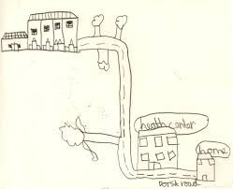 | Maths  What do you do every day? Can you draw a timeline to show what time you do different activities? For example, 7 o’clock – Eat breakfast, 9 o’clock – Go to school
Topic  Make a family tree showing all your family members with photographs or drawings. Talk about the relationship between yourself and each family member. | Topic  How do you get to school? Can you create a map to show the way you get to school? Use your map on your journey –does it work? | Topic  Decorate cardboard cutouts of people to look like your family members. Use fabrics, sequins, wool and other materials to create clothing and features. Can your family recognise themselves?
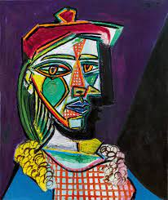
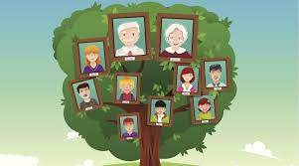
Hedgehogs Home Learning
Term 1

