Squirrel Class - Well Being Activity
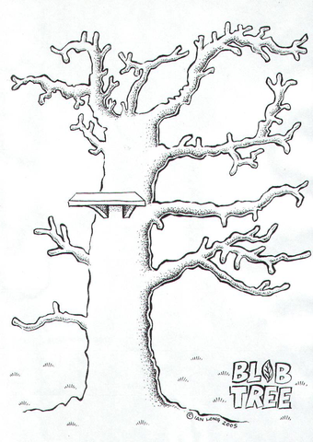
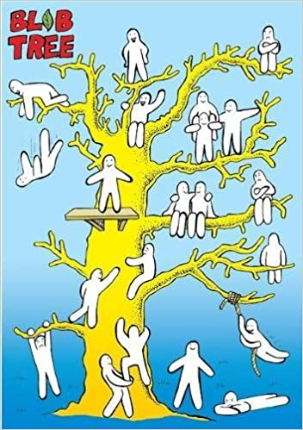

Squirrel Class drew emoji’s for their feelings throughout the day along an empty Blob Tree. Can you try this at home with your child? Discuss how they felt throughout the day and why? Where would they draw themselves along the tree and why?

