Decorate a shoebox and fill with 5 of your favourite things

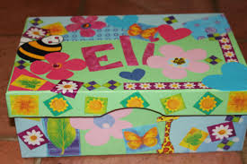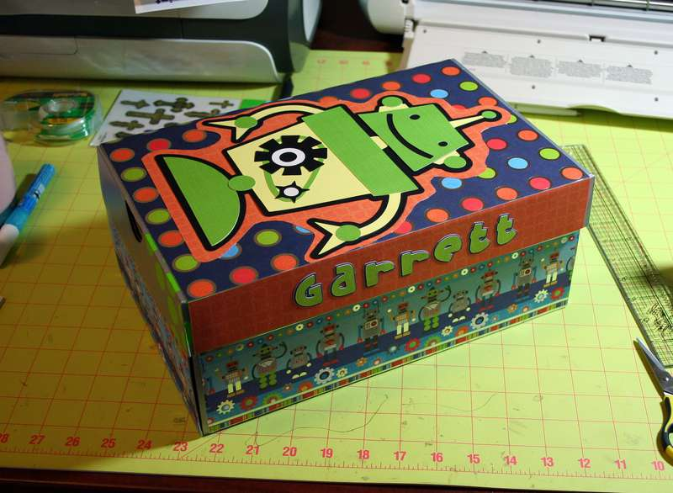

Find a shoebox and decorate it however you like. Your favourite colours / patterns / stickers. Something that shows it is yours. Then fill it with five of your favourite things.

For example – Favourite toy / Story / Photo of your family / Teddy / Drawing

Bring this in with you when we start school and share with your teachers and friends. Provides great speaking and listening opportunities for all.

