Getting ready for school

How many of these can you practice this summer?

Eating

I can you use a knife and fork?

I can opening wrappers and packaging?

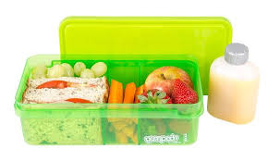

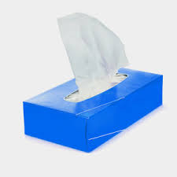

Self-Care

I know when I need to wash my hands.

I can wipe my own nose.

I can ask for help when I don’t feel well.

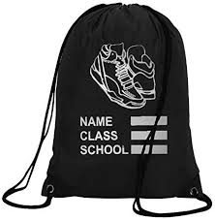

Changing

I can put on my own coat.

I can put on my socks and shoes.

I can put on my own school uniform independently.

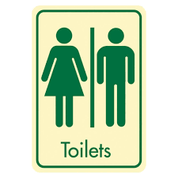

I can go to the on my own, wipe myself and flush the toilet.

I can wash and dry my hands without help.