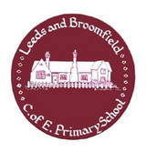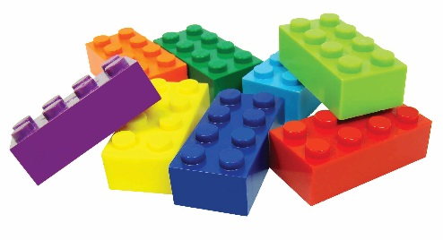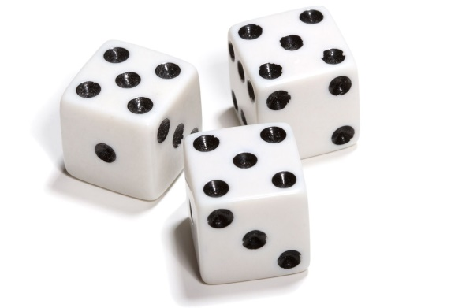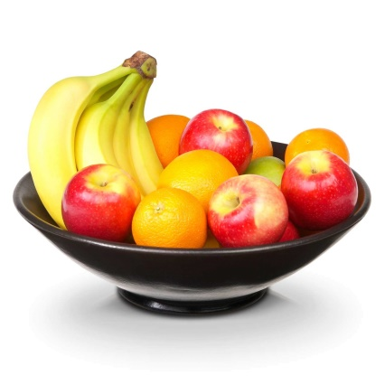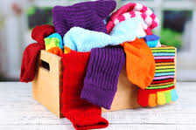

**Maths in Early Years**



**Shape:**

* **Going on a shape hunt around the home and outside. Can you find a …….?**
* **Talking about the number of sides and corners each shape has. Which shape has 3 corners and 3 sides?**
* **Make repeating patterns using vegetables on a plate – what would come next? Look for repeating patterns on paper/clothing/outside.**

**Number:**

* **Counting up and down the stairs – counting forwards and backwards from 0-20.**
* **Sorting socks by colour, size, pattern and pairs – counting in 2’s to find how many.**
* **Using dice for children to see what numbers look like by counting the spots. Put numbers in order**
* **Looking for numbers all around when out and about – say number names.**

**Measures:**

* **Using items from kitchen cupboards – children to hold them and compare weights. Which one is heavier/lighter?**
* **Ordering items by height. Put taller things at the back of the shelf, shorter items at the front.**
* **Who is the tallest in your house? How many hands long is the settee? Who has the longest feet?**

**Calculations:**

* **Playing board games so children can add and take-away numbers to find answers.**
* **Count how many apples and bananas in the fruit bowl – how many altogether? What happens if I eat one?**
* **Build a Lego tower and count the total of bricks. Build another with one with 1 more /1 less bricks. How many bricks now?**