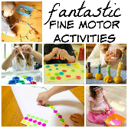Fine Motor
Mark Making
Draw on the floor / vertical positions / at a table
Play Cards
Draw round hands and feet
Play o’s and x’s.
Shopping lists
Doing up buttons
Reading and Writing in the Early Years
Use tweezers to pick up small objects
Take coins out of purse
Playdough roll,squeeze,cut
Building with Duplo / construction

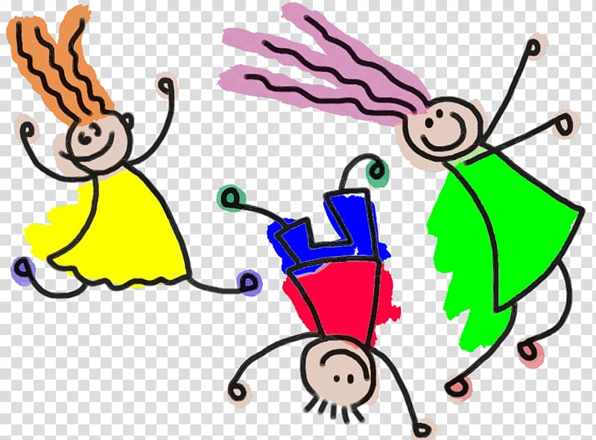
Reading
Rhyming Games / Play animal / letter snap / Memory games / Actions Games – What’s the time Mr Wolf / Look for letter in the environment – number plates / Find objects when out in the environment / Make up stories

